WATER METER INSTALLATION

Dear Resident,

Thank you for your cooperation in regards to the installation of a water meter at this premises.

Your new water meter will provide many advantages to you and the condominium corporation.

- Leak detector on the meter allows you to check your home for water leaks
- Allows homeowners to monitor their consumption
- Is the only way to determine if there are distribution leaks – compare the amount being pumped to the amount being used
- Will help the condominium corporation mange the water treatment plant

If there are any concerns with your installation please advise Ray at 403-792-2169 or lbresort@telus.net.

How to Read Your Meter
INSIDE YOUR HOME
OUTSIDE YOUR HOME
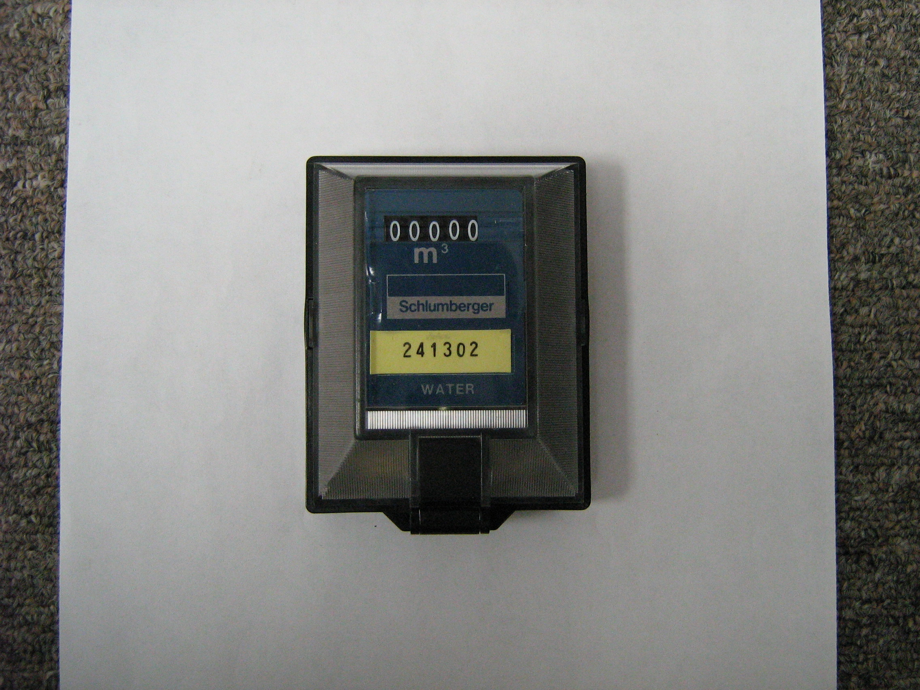
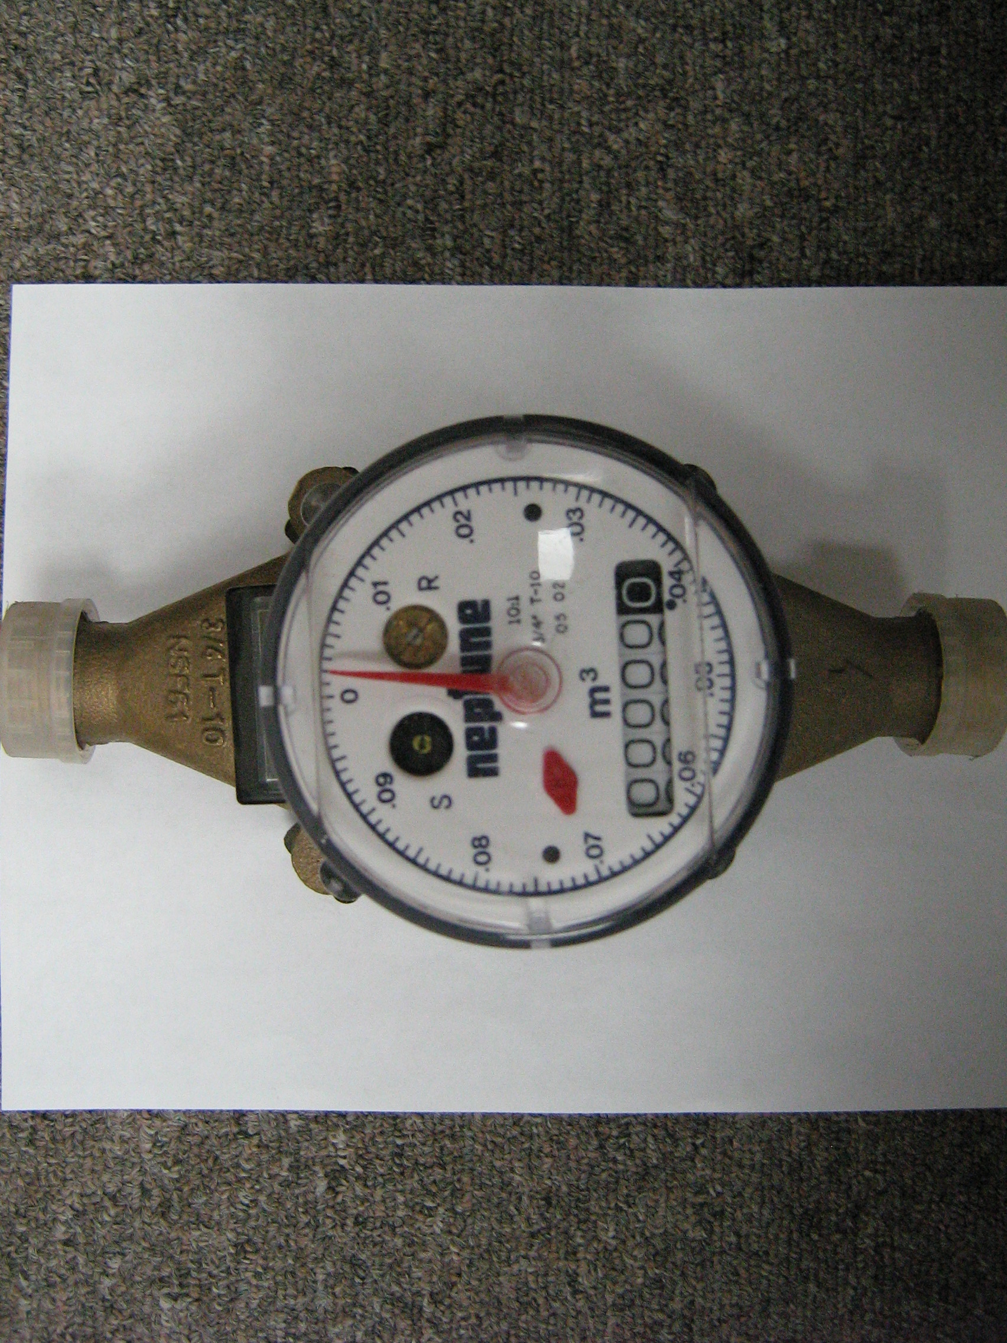
100 Litre Increments
1000 Litre (1M3) Increments

Leak Detector – Ensure all water is shutoff in your home and if this is turning there is still water running!

